Exercise 1 Creating the Visual Studio Projects and Defining the Custom Web Server Control

In this exercise, you create the projects used by this practice. You also write the code for the custom server control.

1. Open Visual Studio and create a new website called CustomControlLab

2. Add an ASP.NET Server Control project to your solution. Name this project MyCustomControls.

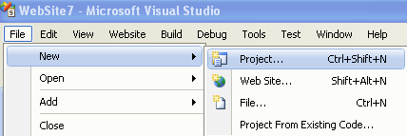

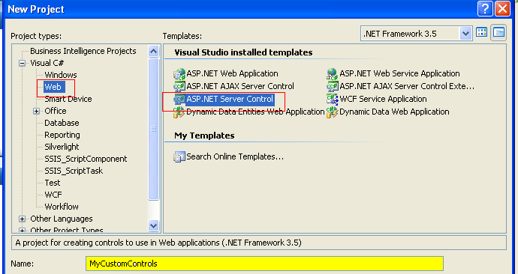

3. Rename ServerControl1 to StateListControl by right-clicking the file in Solution Explorer and choosing Rename. When asked if you would like to rename the class and reference, select Yes.

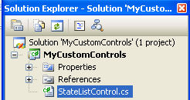

4. Open the StateListControl class file.

- Delete the Text property
- Delete the RenderContents method.
- Change the StateListControl class to inherit from DropDownList.
- Remove the DefaultProperty attribute from the class declaration
- Change the ToolboxData attribute to use the text StateListControl for the tags instead of ServerControl1.
- Add the ID property to the generated markup for the control.

The final scrip is:

using System;
using System.Collections.Generic;
using System.ComponentModel;
using System.Linq;
using System.Text;
using System.Web;
using System.Web.UI;
using System.Web.UI.WebControls;

namespace MyCustomControls
{
[ToolboxData(@"<{0}:StateListControl ID=""StateListControl1"" runat=""server""></{0}:StateListControl>")]

public class StateListControl : DropDownList
{
[Bindable(true)]
[Category("Appearance")]
[DefaultValue("")]
[Localizable(true)]
}
}

Delete the following ones because there are not needed for this example

using System;
using System.Collections.Generic;
using System.ComponentModel;
using System.Linq;
using System.Text;
using System.Web;

6. Add code to the constructor of the StateListControl class to create a ListItem for each state. Add the ListItems to the Items collection of the DropDownList. The ListItem for each state displays the full name of the state, but the posted value is the two-character state abbreviation. The following is an example.

using System.Web.UI;
using System.Web.UI.WebControls;

namespace MyCustomControls
{
[ToolboxData(@"<{0}:StateListControl ID=""StateListControl1""
runat=""server"">
</{0}:StateListControl>")]

public class StateListControl : DropDownList
{
public StateListControl()
{
this.Items.Add(new ListItem("Alabama", "AL"));
this.Items.Add(new ListItem("Alaska", "AK"));
this.Items.Add(new ListItem("Arizona", "AZ"));
this.Items.Add(new ListItem("Arkansas", "AR"));
this.Items.Add(new ListItem("California", "CA"));
//and more ...
}
}
}

7. Build the MyCustomControls project. Also, note that you do not need to expose the Items property or manage its ViewState. That is taken care of already by the base class (DropDownList). Users can add and remove items from the default list of states that the control exposes.

8. Inside the website, add the StateListControl to the Toolbox. You can do this one of two ways.

a) One way is to add a reference to MyCustomControls by right-clicking the website, selecting Add Reference, choosing the Projects tab, and selecting MyCustomControls.

b) Alternatively, you could right-click the Toolbox and select Choose Items. You would then browse and locate the MyCustomControls.dll assembly.

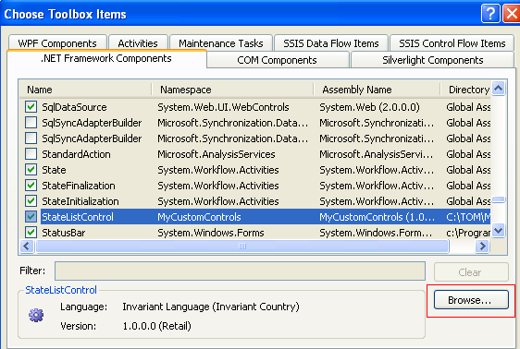

Note that if you chose the Add Reference option, you might have to rebuild the solution to get the control to show in the Toolbox. You might also have to switch the page from Source view to Design view.

9. Open the Default.aspx page. Delete the contents already inside the BodyContent content control.

10. Drag a StateListControl from the Toolbox onto the page. This will register the control with the page and add it to the markup.

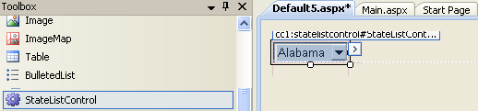

11. Add a Button control and a Label control to the page to demonstrate adding to the StateListControl, handling postback, and displaying the user’s selection. Your markup inside the BodyContent for the page should look as follows:

<cc1:StateListControl ID="StatListControl1" runat="server"></cc1:StateListControl>
<br />

<asp:Button ID="ButtonSubmit" runat="server" Text="Submit" />
<br />

<asp:Label ID="LabelSelected" runat="server" Text=""></asp:Label>

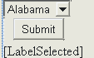

12. Switch to Design view for the page, and double-click the Submit button. This should take you to the code-behind file for the page and generate an event handler for the button’s click event. Add code to this event to render the selected text and value of the StateListControl to the LabelSelected control.

13. Add a Page_Load event to the page (in C# it should already be there). Add code to this event to add an item to the StateListControl if the request is not a postback.

public partial class _Default : System.Web.UI.Page
{
protected void Page_Load(object sender, EventArgs e)
{
if (!IsPostBack)
{
\\ you may add more options to the control
StateListControl1.Items.Add(new ListItem("Michigan", "MI"));
}
}

protected void ButtonSubmit_Click(object sender, EventArgs e)
{
LabelSelected.Text= StateListControl1.SelectedItem.Text + ", " +
StateListControl1.SelectedItem.Value;
}
}

14. Make sure the website is set as the startup project. (Right-click the project in Solution Explorer and choose Set As StartUp Project.)

Run the website. You should be able to test the control in a browser.

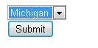

When you click Submit it will show Michigan, MI

